**A Lightweight Secure Data Sharing Scheme for Mobile Cloud Computing**

**ABSTRACT:**

With the popularity of cloud computing, mobile devices can store/retrieve personal data from anywhere at any time. Consequently, the data security problem in mobile cloud becomes more and more severe and prevents further development of mobile cloud. There are substantial studies that have been conducted to improve the cloud security. However, most of them are not applicable for mobile cloud since mobile devices only have limited computing resources and power. Solutions with low computational overhead are in great need for mobile cloud applications. In this paper, we propose a lightweight data sharing scheme (LDSS) for mobile cloud computing. It adopts CP-ABE, an access control technology used in normal cloud environment, but changes the structure of access control tree to make it suitable for mobile cloud environments. LDSS moves a large portion of the computational intensive access control tree transformation in CP-ABE from mobile devices to external proxy servers. Furthermore, to reduce the user revocation cost, it introduces attribute description fields to implement lazy-revocation, which is a thorny issue in program based CP-ABE systems. The experimental results show that LDSS can effectively reduce the overhead on the mobile device side when users are sharing data in mobile cloud environments.

**EXISTING SYSTEM:**

* In general, we can divide these approaches into four categories: simple ciphertext access control, hierarchical access control, access control based on fully homomorphic encryption and access control based on attribute-based encryption (ABE). All these proposals are designed for non-mobile cloud environment
* Tysowski et al. considered a specific cloud computing environment where data are accessed by resource-constrained mobile devices, and proposed novel modifications to ABE, which assigned the higher computational overhead of cryptographic operations to the cloud provider and lowered the total communication cost for the mobile user.

**DISADVANTAGES OF EXISTING SYSTEM:**

* Data privacy of the personal sensitive data is a big concern for many data owners.
* The state-of-the-art privilege management/access control mechanisms provided by the CSP are either not sufficient or not very convenient.
* They cannot meet all the requirements of data owners.
* They consume large amount of storage and computation resources, which are not available for mobile devices
* Current solutions don’t solve the user privilege change problem very well. Such an operation could result in very high revocation cost. This is not applicable for mobile devices as well. Clearly, there is no proper solution which can effectively solve the secure data sharing problem in mobile cloud.

**PROPOSED SYSTEM:**

* We propose a Lightweight Data Sharing Scheme (LDSS) for mobile cloud computing environment.
* The main contributions of LDSS are as follows:
* We design an algorithm called LDSS-CP-ABE based on Attribute-Based Encryption (ABE) method to offer efficient access control over ciphertext.
* We use proxy servers for encryption and decryption operations. In our approach, computational intensive operations in ABE are conducted on proxy servers, which greatly reduce the computational overhead on client side mobile devices. Meanwhile, in LDSS-CP-ABE, in order to maintain data privacy, a version attribute is also added to the access structure. The decryption key format is modified so that it can be sent to the proxy servers in a secure way.
* We introduce lazy re-encryption and description field of attributes to reduce the revocation overhead when dealing with the user revocation problem.
* Finally, we implement a data sharing prototype framework based on LDSS.

**ADVANTAGES OF PROPOSED SYSTEM:**

* The experiments show that LDSS can greatly reduce the overhead on the client side, which only introduces a minimal additional cost on the server side.
* Such an approach is beneficial to implement a realistic data sharing security scheme on mobile devices.
* The results also show that LDSS has better performance compared to the existing ABE based access control schemes over ciphertext.
* Multiple revocation operations are merged into one, reducing the overall overhead
* In LDSS, the storage overhead needed for access control is very small compared to data files.

**SYSTEM ARCHITECTURE:**

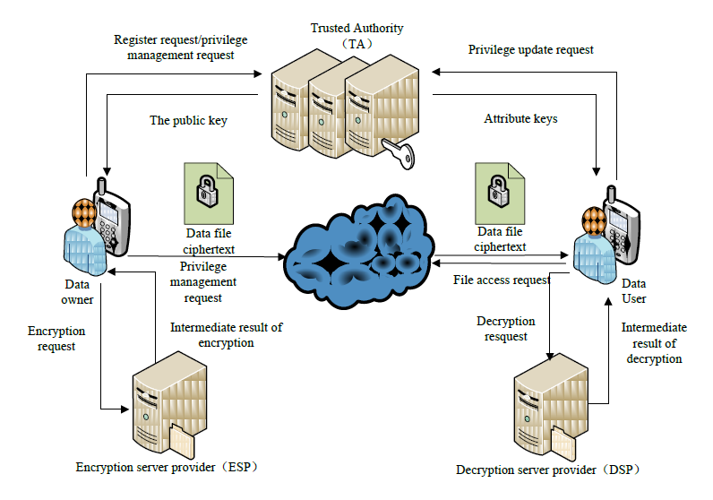

**MODULES:**

* System Framework
* Data Owner
* Data User
* Trusted Authority
* Cloud Service Provider

**MODULES DESCRIPTION:**

**System Framework:**

The development of cloud computing and the popularity of smart mobile devices, people are gradually getting accustomed to a new era of data sharing model in which the data is stored on the cloud and the mobile devices are used to store/retrieve the data from the cloud. In these applications, people (data owners) can upload their documents and other files to the cloud and share these data with other people (data users) they like to share. CSPs also provide data management functionality for data owners. Since personal data files are sensitive, data owners are allowed to choose whether to make their data files public or can only be shared with specific data users. Clearly, data privacy of the personal sensitive data is a big concern for many data owners. We propose LDSS, a framework of lightweight data sharing scheme in mobile cloud. It has the following six components. (1)Data Owner (DO) (2) Data User (DU) (3) Trust Authority (TA) (4) Encryption Service Provider (ESP) (5) Decryption Service Provider (DSP) (6) Cloud Service Provider (CSP).

**Data Owner (DO):**

When the data owner (DO) registers on TA, TA runs the algorithm Setup() to generate a public key PK and a master key MK. PK is sent to DO while MK is kept on TA itself. DO defines its own attribute set and assigns attributes to its contacts. All these information will be sent to TA and the cloud. TA and the cloud receive the information and store it. DO uploads data to the mobile cloud and share it with friends. DO determines the access control policies. DO sends data to the cloud. Since the cloud is not credible, data has to be encrypted before it is uploaded. The DO defines access control policy in the form of access control tree on data files to assign which attributes a DU should obtain if he wants to access a certain data file.

**Data User (DU):**

DU logins onto the system and sends, an authorization request to TA. The authorization request includes attribute keys (SK) which DU already has. TA accepts the authorization request and checks the request and a generate attribute keys (SK) for DU. DU sends a request for data to the cloud.Cloud receives the request and checks if the DU meets the access requirement. DU receives the ciphertext, which includes ciphertext of data files and ciphertext of the symmetric key. DU decrypt the ciphertext of the symmetric key with the assistance of DSP. DU uses the symmetric key to decrypt the ciphertext of data files.

**Trusted Authority:**

To make LDSS feasible in practice, a trusted authority (TA) is introduced. It is responsible of generating public and private keys, and distributing attribute keys to users. With this mechanism, users can share and access data without being aware of the encryption and decryption operations. We assume TA is entirely credible, and a trusted channel exists between the TA and every user. The fact that a trusted channel exists doesn’t mean that the data can be shared through the trusted channel, for the data can be in a large amount. TA is only used to transfer keys (in a small amount) securely between users. In addition, it’s requested that TA is online all the time because data users may access data at any time and need TA to update attribute keys.

**Cloud Service Provider:**

CSP stores the data for DO. It faithfully executes the operations requested by DO, while it may peek over data that DO has stored in the cloud. DU sends a request for data to the cloud. Cloud receives the request and checks if the DU meets the access requirement. If DU can’t meet the requirement, it refuses the request; otherwise it sends the ciphertext to DU. CSP manages the Uploaded Files.

**SYSTEM REQUIREMENTS:**

**HARDWARE REQUIREMENTS:**

* System : Pentium Dual Core.
* Hard Disk : 120 GB.
* Monitor : 15’’ LED
* Input Devices : Keyboard, Mouse
* Ram : 1 GB

**SOFTWARE REQUIREMENTS:**

* Operating system : Windows 7.
* Coding Language : JAVA/J2EE
* Tool : Netbeans 7.2.1
* Database : MYSQL

**REFERENCE:**

Ruixuan Li, *Member*, *IEEE*, Chenglin Shen, Heng He, Zhiyong Xu, and Cheng-Zhong Xu, *Member*, *IEEE,* “A Lightweight Secure Data Sharing Scheme for Mobile Cloud Computing”, **IEEE Transactions on Cloud Computing, 2017.**